Robotics Control Architecture: Raspberry Pi 5 Master Guide
1. The Foundation: Reading the Physical Button
Because the Raspberry Pi 5 uses a new internal architecture (the RP1 chip), older libraries like RPi.GPIO are obsolete. The modern, robust standard is gpiozero.
- How it works: gpiozero automatically handles the background listening for button presses using hardware interrupts.
- The Analogy: Think of gpiozero as an alarm system. Your Pi doesn't need to constantly check if the door is open; it just goes about its business until the alarm physically rings to wake it up.
Basic Button Code
from gpiozero import Button
from signal import pause

# Button wired to GPIO 14 and Ground
button = Button(14, hold_time=5, bounce_time=0.05)

def long_press():
print("5-second hold detected!")

def short_press():
print("Short press detected!")

button.when_held = long_press
button.when_released = short_press

pause() # Keeps script alive
2. Competition Reliability: Auto-Starting on Boot
In a competition, you cannot rely on Wi-Fi or SSH to start your robot. You need the Pi to run your script the moment it gets power. We achieve this using systemd.
- The Analogy: Systemd is the robot's relentless manager. If the robot turns on, the manager starts the script. If the script crashes due to a bug, the manager instantly restarts it (Restart=always).
The systemd Service File (/etc/systemd/system/robot.service):
[Unit]
Description=Robot Main Control Loop
After=network.target

[Service]
ExecStart=/usr/bin/python3 /home/YOUR_USERNAME/main.py
WorkingDirectory=/home/YOUR_USERNAME
StandardOutput=inherit
StandardError=inherit
Restart=always
User=YOUR_USERNAME

[Install]
WantedBy=multi-user.target

3. The "Control Loop" and the Blocking Trap
Autonomous robots run on a continuous heartbeat: a while True: loop that reads sensors and moves motors.
- The Trap: If you put a heavy task (like searching for an AprilTag in a video feed) directly inside this main loop, the loop "blocks" (freezes) while it waits. Your robot will respond to button presses sluggishly, or your video feed will lag by several seconds.
- The Solution: We must split the robot's brain into parallel timelines using Threads and Processes.
4. Threads vs. Processes: The Core Architecture
Python has a limitation called the Global Interpreter Lock (GIL), meaning we have to be strategic about how we split tasks.
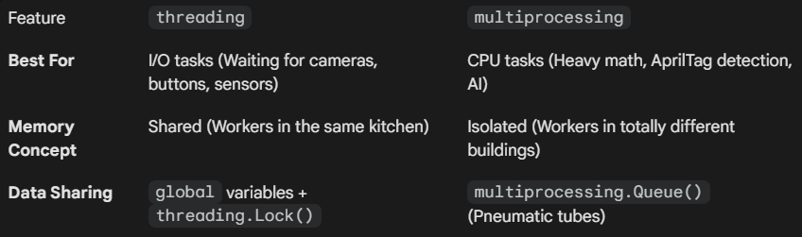
Threading: The Camera Fix
We put the webcam on its own Thread. It constantly snaps photos and updates a global variable.
- The Analogy: The camera thread is a sous-chef constantly chopping fresh vegetables. When the main loop (the head chef) needs vegetables, it just grabs the freshest pile off the counter. It never has to wait for the chopping to happen.
- The Lock(): We use a Lock so the head chef doesn't grab the vegetables while the sous-chef's knife is actively coming down.
Multiprocessing: The Heavy Math Fix
We put the AprilTag math on a separate Process so it gets its own dedicated CPU core.
- The Analogy: The main loop puts a photo into a pneumatic tube (Queue) and sends it to the math department in another building. The math department does the complex geometry and sends the coordinates back down a second tube. The main loop keeps driving the robot smoothly while it waits for the tube to arrive.
5. The Ultimate Hybrid Competition Code
This template combines all concepts: the gpiozero background thread, the camera grabbing thread, the heavy math process, and the main control loop.
import time
import threading
import multiprocessing
import cv2
from gpiozero import Button

# --- SHARED MEMORY (For Threads) ---
is_alg_running = False
latest_frame = None
frame_lock = threading.Lock()

# --- 1. THE BUTTON THREAD (Auto-managed by gpiozero) ---
def toggle_state():
global is_alg_running
is_alg_running = not is_alg_running
print(f"State changed: {is_alg_running}")

# --- 2. THE CAMERA THREAD ---
def camera_worker():
global latest_frame
cap = cv2.VideoCapture(0)

# Hardware downscale for performance
cap.set(cv2.CAP_PROP_FRAME_WIDTH, 640)
cap.set(cv2.CAP_PROP_FRAME_HEIGHT, 480)

while True:
ret, frame = cap.read()
if ret:
with frame_lock:
latest_frame = frame
time.sleep(0.01)

# --- 3. THE HEAVY MATH PROCESS ---
def heavy_math_worker(in_queue, out_queue):
while True:
frame = in_queue.get() # Waits for a frame
time.sleep(0.5) # Simulating heavy AprilTag math
out_queue.put({"x": 320, "y": 240, "found": True})

# --- 4. THE MAIN CONTROL LOOP ---
if __name__ == '__main__':
# Setup communication tubes
frame_tube = multiprocessing.Queue()
result_tube = multiprocessing.Queue()

# Start background workers
multiprocessing.Process(target=heavy_math_worker, args=(frame_tube, result_tube), daemon=True).start()
threading.Thread(target=camera_worker, daemon=True).start()

# Setup button
btn = Button(14, bounce_time=0.05)
btn.when_released = toggle_state

# The Heartbeat
try:
while True:
if is_alg_running:
# 1. Safely grab the newest frame
current_frame = None
with frame_lock:
if latest_frame is not None:
current_frame = latest_frame.copy()

# 2. Send to math department if they aren't busy
if current_frame is not None and frame_tube.empty():
frame_tube.put(current_frame)

# 3. Check for returned coordinates
if not result_tube.empty():
tag_data = result_tube.get()
print(f"Drive to: {tag_data['x']}, {tag_data['y']}")
else:
pass # Robot is paused, send stop commands to motors here

time.sleep(0.02)

except KeyboardInterrupt:
print("Safely shutting down...")
6. Managing Wide-Angle Cameras
Wide-angle cameras process massive amounts of data. Pushing high-resolution images through Python multiprocessing queues will cripple your frame rate.
- Always use cap.set() to command the camera hardware to step down to 640x480 before the loop starts.
- If the camera firmware rejects the command, catch it using frame.shape and use cv2.resize() to manually shrink the image before sending it to your heavy math process.

